**SALESFORCE PROJECT**

**MILKEASE**

* **Phase 5:   Apex Programming (Developer)**

👉 Goal **:**  Add advanced logic.

* **Classes & Objects**:-
* Create BookingService.class.
* Add methods like:
  + checkOverlap() → validate booking dates for dairy trucks.

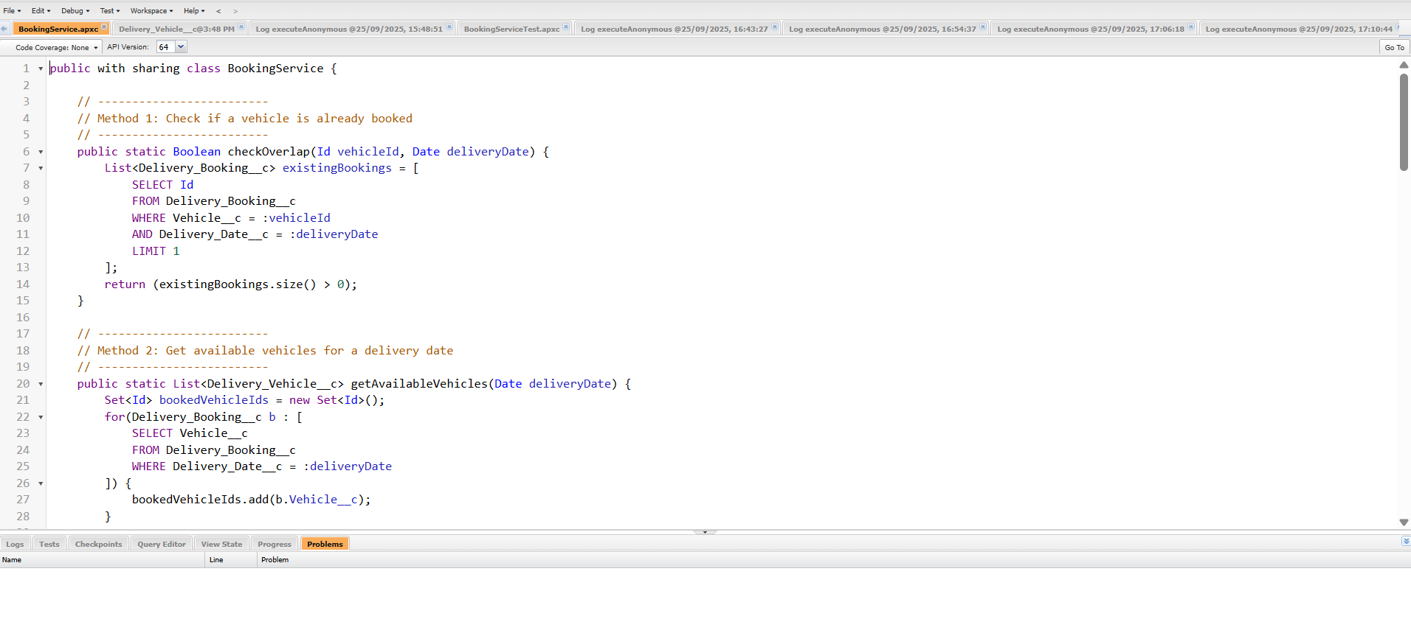

* + getAvailableVehicle() → return list of available trucks.

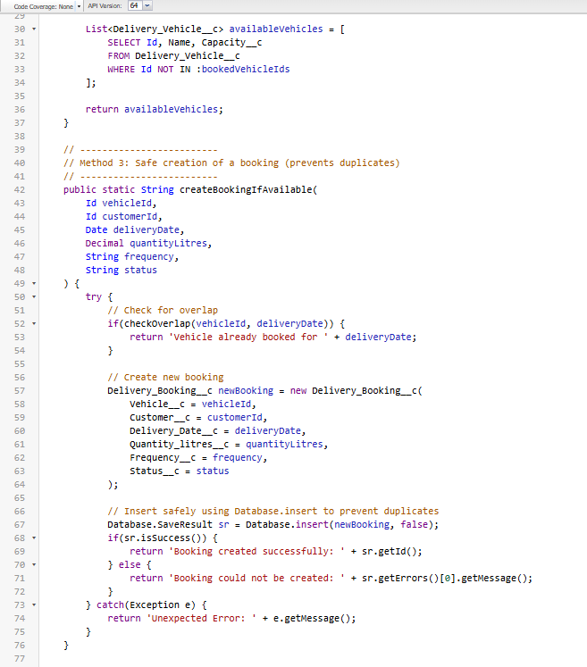

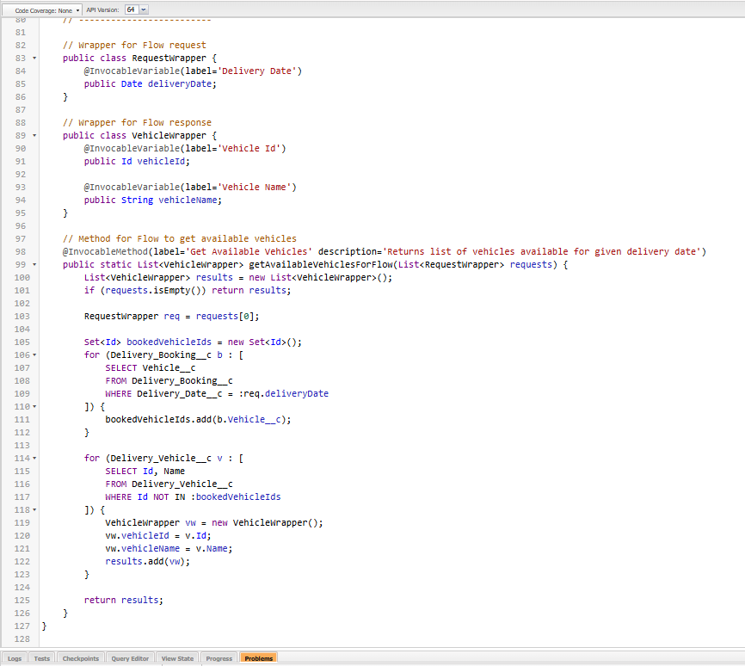

* **Apex Triggers**:-
* Create BookingTrigger.trigger on Delivery_Booking__c.

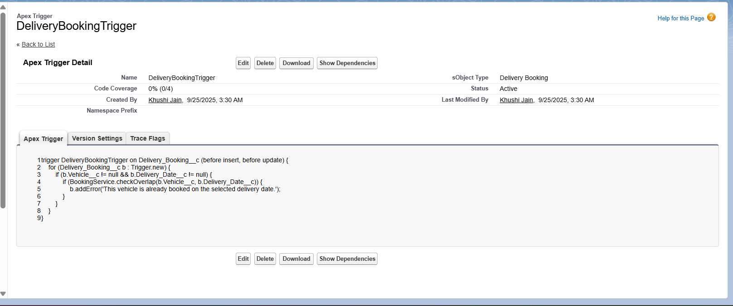

* **SOQL & Collections**:-
* SOQL Query to Get Available Vehicles
* Use Set<Id> to Avoid Duplicates
* Use Map<Id, Delivery_Vehicle__c> for Quick Access

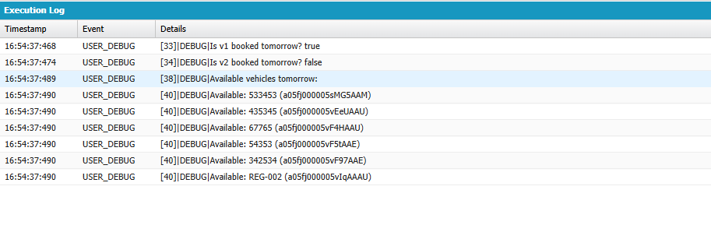

* **Control Statements**:-
* If Vehicle_booking dates overlap → throw error.

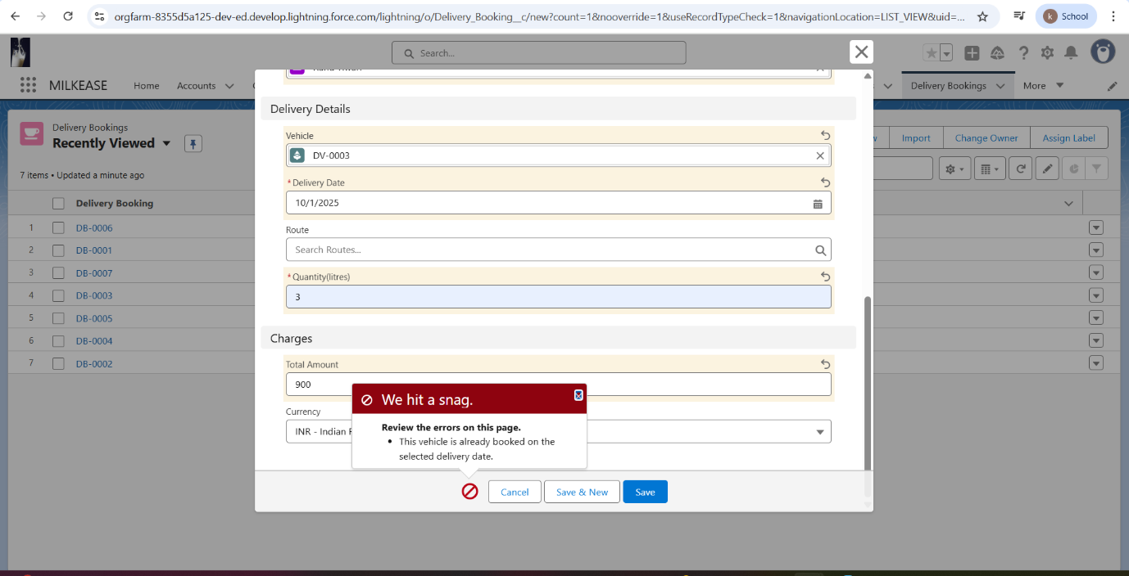

* **Exception Handling**:-
* Avoid runtime crashes.

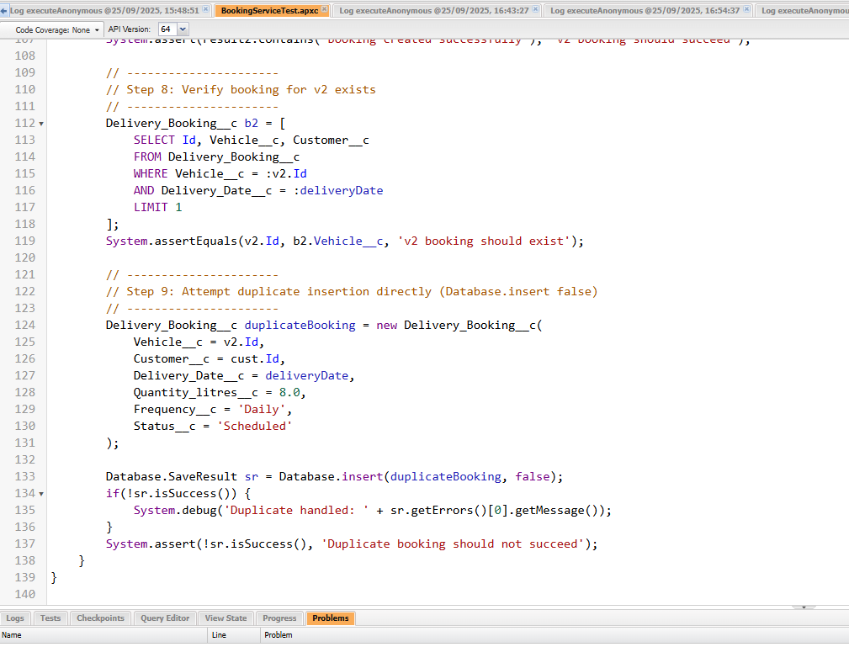

* **Test Classes**:-
* Verify triggers and classes work.
* Salesforce requires 75% coverage for deployment.

